TAYSIDE MACHINERY LTD
SCOTLAND
TELE: 0044 (0) 1382 200797 FAX: 0044 (0) 1382 202853
e-mail: sales@taysidemachinery.co.uk website: www.taysidemachinery.co.uk

Mazak Integrex 200Y CNC Lathe
ST3519

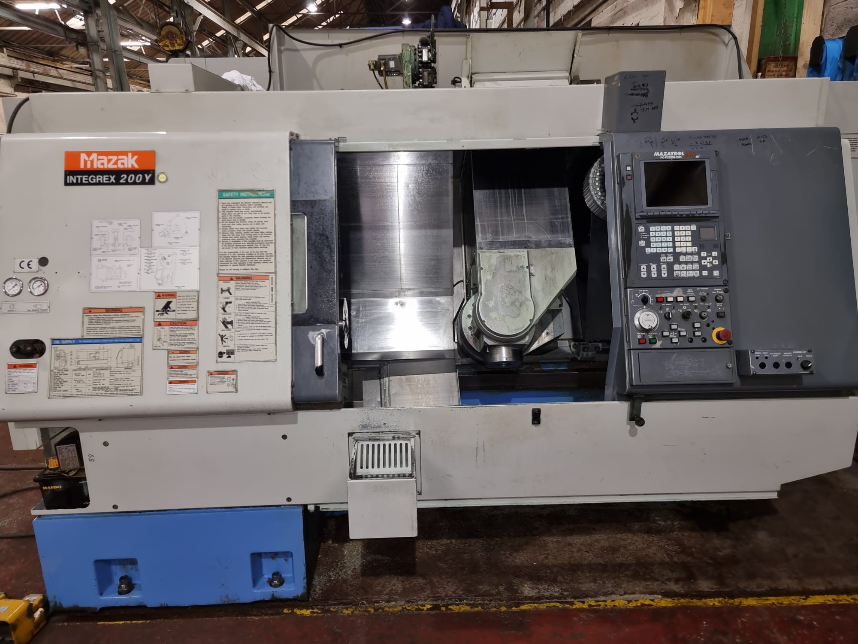

Mazak Integrex 200Y CNC Lathe

Model: Integrex 200Y
Year: 2001
Control: Mazatrol PC-Fusion- CNC 640 T

Swing over Bed: 540mm
Max. Machining Dia.: 520mm
Max. machining length: 1018mm

‘X’ axis Travel: 530mm
‘Y’ axis Travel: 140mm
‘Z; axis Travel: 1065mm

Spindle Bore: 61mm dia.
Mian Spindle Speeds: 5000 RPM
Milling Spindle Speeds: 6000 RPM

Machine with:
210mm 3-jaw power chuck
40 station toolchanger
‘C’ axis and milling
Tailstock
Tool Pre- Setter

